AGGREGATION FUNCTIONS
These Functions can apply only in Measure why because it returns a single value.
Input Data:
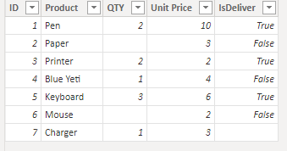
1)SUM: SUM Function Adds all the numbers in a column.
Syntax: SUM(<column>)
Dax Function: SUM = SUM(Aggrigate_sum_avg[QTY])
Note: It support decimal and numeric data type.
Output:
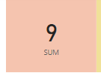
2)SUMX: Returns the Sum of an expression evaluated for each row in a table.
Syntax: SUMX(<table>, <expression>)
NOTE: Diff between sum and sumx is,
1)these two are Measures,
2)Sum only requires a single column to perform aggregation. But sumx should require table and expression that’s evaluated each row of the table.
3)Sum works on already existing column but sumx works on calculated column.
4)If we want work add calculated column go to SUMX.
Dax Function: SUMX = SUMX(Aggrigate_sum_avg,Aggrigate_sum_avg[QTY]*Aggrigate_sum_avg[Unit Price])
Output:
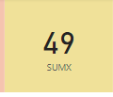
3)MIN: Returns the smallest numeric value in a column.
Syntax: MIN(<column>)
NOTE: It support decimal and numeric data type.
Dax Function: MIN = MIN(Aggrigate_min[Unit Price])
Output:
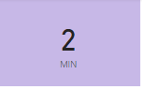
4)MINX: Returns the smallest numeric value of an expression evaluated for each row in a table.
Syntax MINX(<table>, < expression>)
NOTE: Diff between Min and Minx is,
1)these two are Measures,
2)Min only requires a single column to perform aggregation. But Minx should require table and expression that’s evaluated each row of the table.
3)Min works on already existing column but Minx works on calculated column.
4)If we want work add calculated column go to MINX.
Dax Function: MINX = MINX(Aggrigate_min,Aggrigate_min[QTY]*Aggrigate_min[Unit Price])
Output:
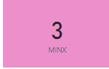
5)MAX: Returns the largest numeric value in a column.
Syntax: MAX(<column>)
NOTE: It support Numeric and decimal datatype columns.
Dax Function: MAX = MAX(Aggrigate_max[Unit Price])
Output:
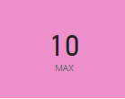

6)MAXX: Returns the largest numeric value of an expression evaluated for each row in a table.
Syntax MAXX(<table>, < expression>)
NOTE: Diff between Max and Maxx is,
1)these two are Measures,
2) Max only requires a single column to perform aggregation. But Maxx should require table and expression that’s evaluated each row of the table.
3) Max works on already existing column but Maxx works on calculated column.
4)If we want work add calculated column go to Maxx.
Dax Function: MAXX = MAXX(Aggrigate_max,Aggrigate_max[Unit Price]*Aggrigate_max[QTY])
Output:
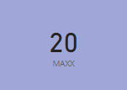

8)AVERAGE: Returns the average of all the numbers in a column.
Syntax: AVERAGE(<column>)
NOTE : It support decimal and numeric data type.
Dax Function: AVERAGE = AVERAGE(Aggrigate_sum_avg[QTY])
Output:
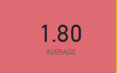
9)AVERAGEX: Calculates the average of a set of expressions evaluated over a table.
Syntax AVERAGEX(<table>,<expression>)
NOTE: Diff between Average and Averagex is,
1)these two are Measures,
2) Average only requires a single column to perform aggregation. But Averagex should require table and expression that’s evaluated each row of the table.
3)Average works on already existing column but Averagex works on calculated column.
4)If we want work add calculated column go to Averagex.
Dax Function: AVERAGEX = AVERAGEX(Aggrigate_sum_avg,Aggrigate_sum_avg[QTY]*Aggrigate_sum_avg[Unit Price])
Output:
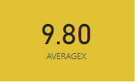
7)COUNT: Counts the number of cells in a column that contains a number.
Syntax: COUNT(<column>)
NOTE: 1)It support decimal, numeric ,character and Date data type..
2)It ignores the blank cells.
Dax Function: Count = COUNT(Aggrigate_sum_avg[QTY])
Output:
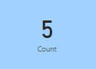
8)COUNTA: A similar to like a COUNT column function, but it supports all the data type columns.
Syntax: COUNTA(<column>)
NOTE: COUNT supports Boolean data type but COUNTA support all data type columns.
Dax Function: CountA = COUNTA(Aggrigate_sum_avg[IsDeliver])
Output:
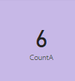
9)COUNX: Calculates the number of cells of a set of expressions evaluated over a table.
Syntax COUNTX(<table>,<expression>)
NOTE: Diff between Count and Countx is,
1)these two are Measures,
2) Count only requires a single column to perform aggregation. But Countx should require table and expression that’s evaluated each row of the table.
3) Count works on already existing column but Countx works on calculated column.
4)If we want work add calculated column go to Countx.
Dax Function: Countx = COUNTX(Aggrigate_sum_avg,Aggrigate_sum_avg[Unit Price]*Aggrigate_sum_avg[QTY])
Output:
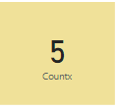
10)COUNTAX: It will work same as COUNTX but it supports any datatype column.
Syntax: COUNTAX(<table>,<expression>)
Dax Function: Countax=COUNTAX(Aggrigate_sum_avg,Aggrigate_sum_avg[IsDeliver])
Output:
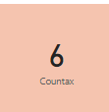

11)COUNTBLANK: Counts the number of blank cells in a column.
Syntax: COUNTBLANK(<column>)
Dax Function: Countblank = COUNTBLANK(Aggrigate_sum_avg[QTY])
Output:

12)DISTINCT COUNT: Counts the number of Unique cells in a column.
Syntax: DISTINCTCOUNT(<column>)
NOTE: Distinct count picks blank cells also, it considers as a distinct cell.
But COUNT ignores blank cells.
Dax Function: Distnictcount=DISTINCTCOUNT(Aggrigate_sum_avg[QTY])
Output: 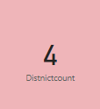

13)DISTINCTCOUNTNOBLANK: Counts the unique number of non-blank values in a column.
Syntax: DISTINCTCOUNTNOBLANK (<column>)
NOTE: In this first return the unique output after that in that result to non-count the any blank values.
Dax Function: Distnictcountnoblank=DISTINCTCOUNTNOBLANK(Aggrigate_sum_avg[QTY])
Output:
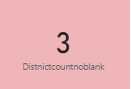
14)COUNTROWS: Counts the number of rows in the specified table.
Syntax: COUNTROWS([<table>])
Dax Function: Countrows=COUNTROWS(Aggrigate_sum_avg)
Output:
